September Campaign Card Suggestions

First Day of Autumn

First Day of Autumn

- Happy Autumn for all of us here at _______ Title!
- LEAVE your troubles at the door!
- Open your escrows with us! You won’t beLEAVE the difference!
- Celebrate Fall by turning over a new leaf and opening your escrows with us!
- Changing seasons, same great service!
- FALL in love with our ____________ (efficiency/service/professionalism/etc.) this Fall!
- It’s almost pumpkin-picking season! When you pick your Escrow Company, please consider us! We’re the pick of the patch!

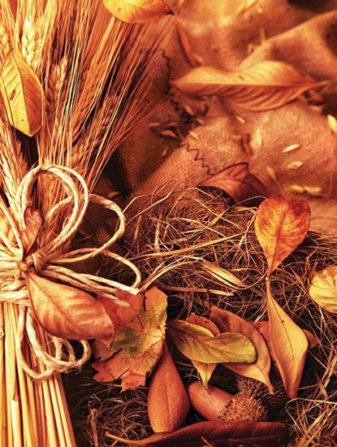

https://www.notecardcafe.com/abundant-harvest

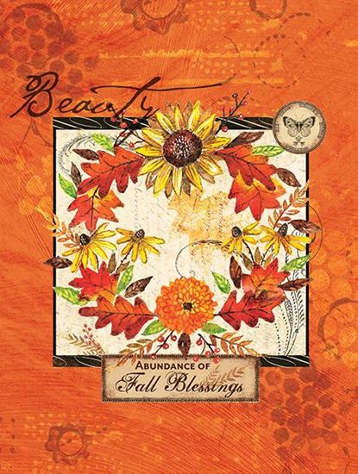

https://www.notecardcafe.com/beauty-wreath

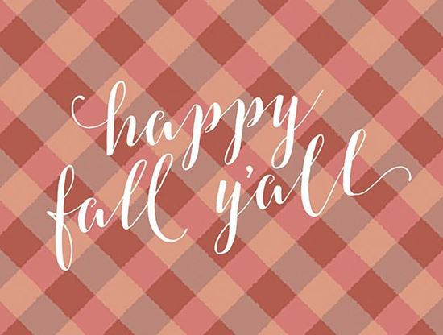

https://www.notecardcafe.com/happy-fall-yall
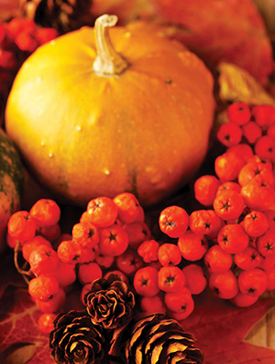

https://www.notecardcafe.com/autumn-yield

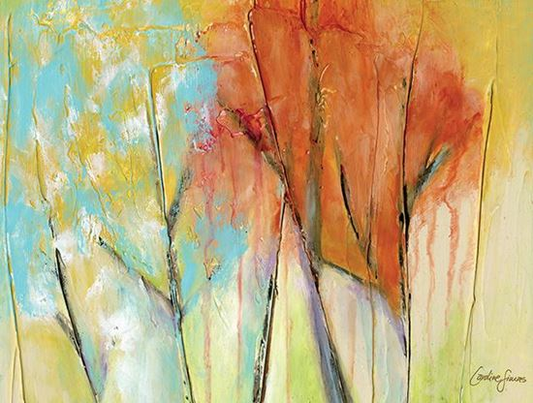

https://www.notecardcafe.com/colorful-canopy
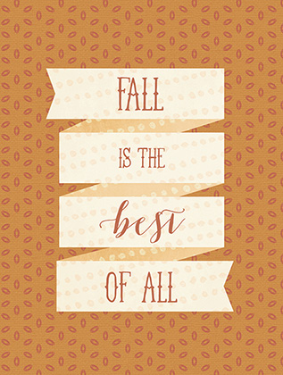

https://www.notecardcafe.com/fall-is-the-best-of-all

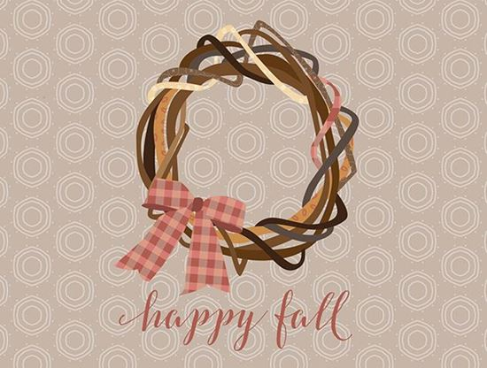

https://www.notecardcafe.com/happy-fall-wreath

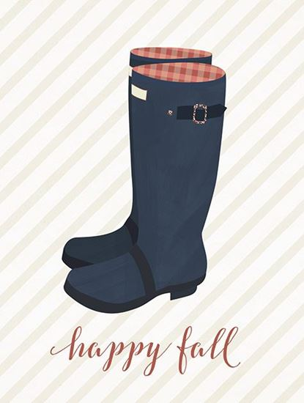

https://www.notecardcafe.com/happy-fall-wellies

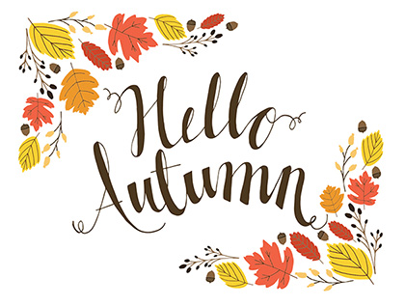

https://www.notecardcafe.com/hello-autumn
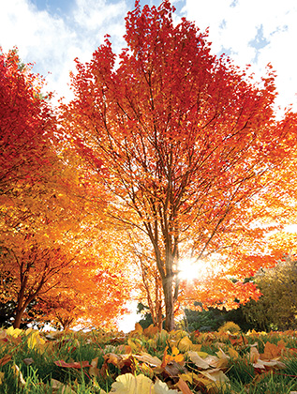

https://www.notecardcafe.com/turning-of-the-leaves

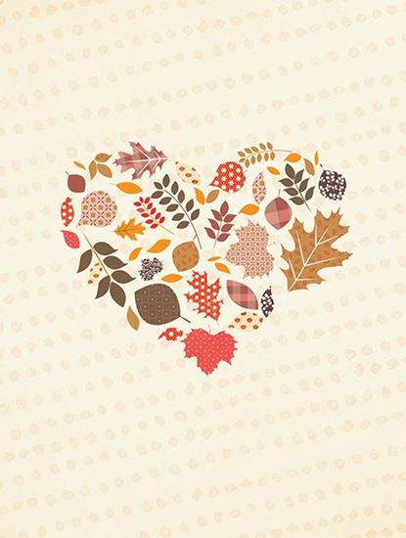

https://www.notecardcafe.com/happy-fall-heart
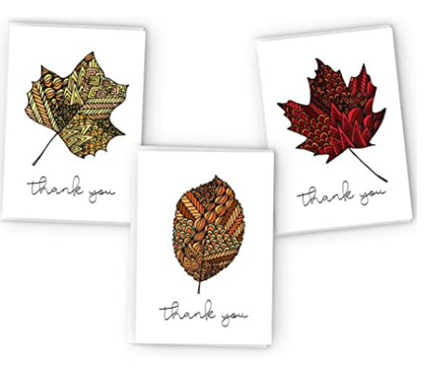
Amazon.com : Autumn Leaves Zentangle Fall Thank You Cards - 24 Cards & Envelopes : Office Products

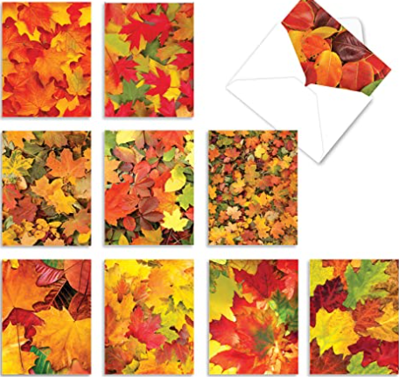
Amazon.com : Leaf a Message - 10 Autumn All Occasion Greeting Cards with Envelopes (4 x 5.12 Inch) - Colorful Fall Leaves, Boxed Inspirational Notecard Set M2009 : Office Products
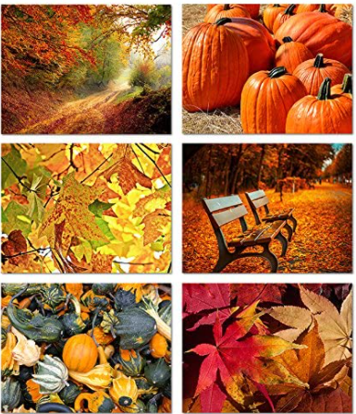
Amazon.com : Autumn Scenes - Blank Greeting Cards - 6 Fall Designs - Includes Card and Envelopes - 5.5"X4.25" (12 Pack) : Office Products

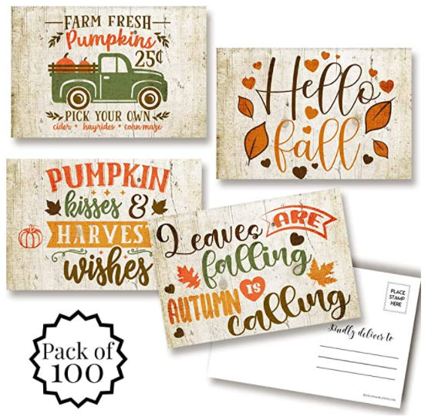

Amazon.com: Pumpkins & Leaves Rustic Fall & Autumn Themed Blank Postcards To Send To Friends & Family, 4"x6" Fill In Notecards (4 different design) by AmandaCreation (100): Kitchen & Dining

