October Campaign Card Suggestions

Halloween

Halloween

- Happy Halloween from all of us here at _________ Title!
- No tricks! Only treats!
- We’re BATTY for your business!
- Bubble, bubble, toil and trouble. Let’s work to make your business double!
- BOO! Don’t be scared! Come say hi this Halloween season! We’d love to meet with you to show you how we can help you grow your business!
- We hope you have a frightfully delightful Halloween!
- When there’s something selling… in your neighborhood… Who you gonna call? ♪♪♪ CALL US! We’ve got your back!
- Halloween can be very scary, but your escrow experience doesn’t have to be! Come work with us and we’ll make sure your transaction goes smoothly!
- Come stop by for a SPELL! Let us show you how we can add value to your business!
- Happy Pumpkin Day! Won’t you pick us?
- Let us give you a SPOOKtacular Escrow Experience this Halloween season!
- Ve vant to vork vith you! (We want to work with you!)
- Come see us at ______ Title! You’ll be SPELL-bound by our service!
- When choosing your Escrow Company, pick us! We’re the pick of the patch!

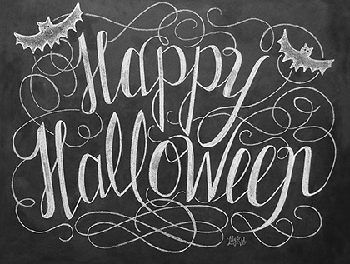

https://www.notecardcafe.com/happy-halloween
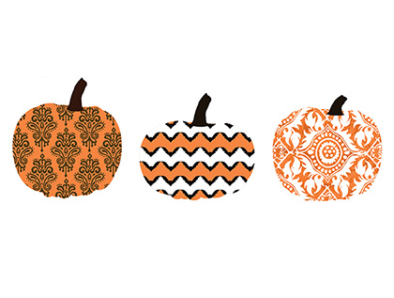
https://www.notecardcafe.com/plump-patterned-pumpkins

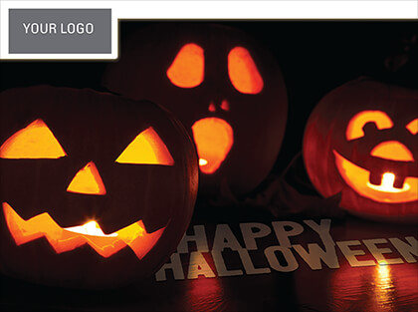

https://www.notecardcafe.com/silly-pumpkins

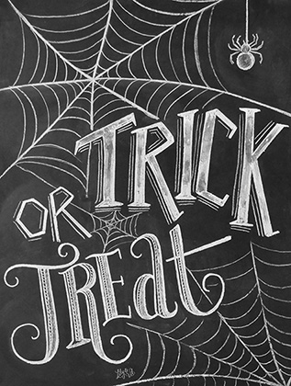

https://www.notecardcafe.com/trick-or-treat

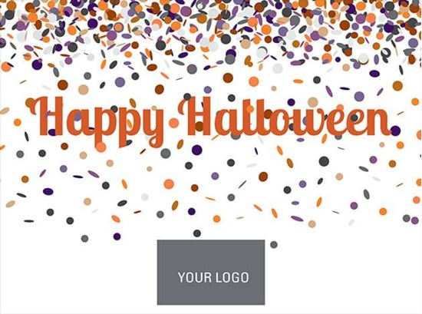

https://www.notecardcafe.com/happy-hallows-eve

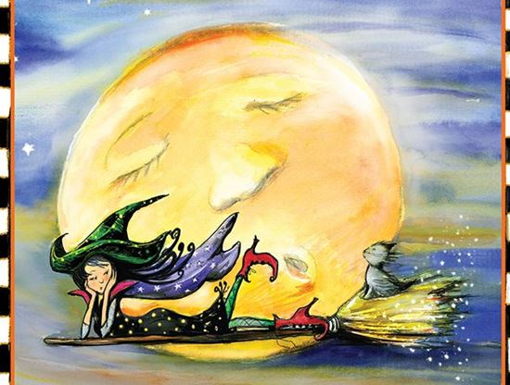

https://www.notecardcafe.com/sleepy-witch-and-moon

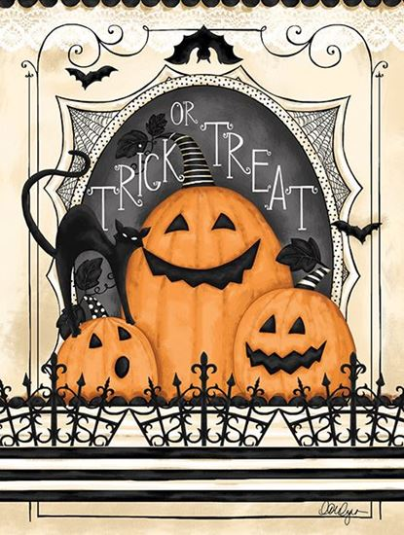

https://www.notecardcafe.com/trick-or-treat-jack-o-lanterns

