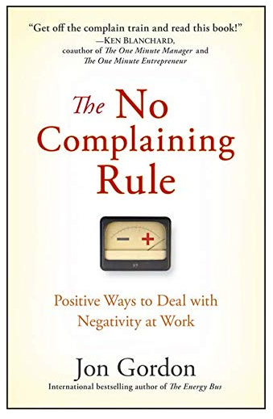

August 2021
Elite Club Book Selection

https://nam04.safelinks.protection.outlook.com/?url=https%3A%2F%2Fwww.amazon.com%2FNo-Complaining-Rule-Positive-Negativity%2Fdp%2F0470279494%2Fref%3Dsr_1_4%3Fdchild%3D1%26keywords%3Djon%2Bgordon%26qid%3D1627523605%26sr%3D8-4&amp;data=04%7C01%7CErin.Goodman%40fnf.com%7C0a4dafdce2b74989e95b08d952349e46%7C8a807b9b02da47f3a903791a42a2285c%7C0%7C0%7C637631208363178570%7CUnknown%7CTWFpbGZsb3d8eyJWIjoiMC4wLjAwMDAiLCJQIjoiV2luMzIiLCJBTiI6Ik1haWwiLCJXVCI6Mn0%3D%7C1000&amp;sdata=7vQKNbXxQkDxQ%2F2njp%2F61JyEZnhWgnaeZ3R%2BsaoCcvQ%3D&amp;reserved=0

Negativity in the workplace costs businesses billions of dollars and impacts the morale, productivity and health of individuals and teams. "In The No Complaining Rule: Positive Ways to Deal with Negativity at Work, Jon Gordon, a bestselling author, consultant and speaker, shares an enlightening story that demonstrates how you can conquer negativity and inspire others to adopt a positive attitude." Based on one company’s successful No Complaining Rule, the powerful principles and actionable plan are practical and easy-to-follow, making this book an ideal read for managers, team leaders and anyone interested in generating positive energy.

