Pending home sales plummet in April, but demand is showing signs of a rebound
PUBLISHED THU, MAY 28 202010:00 AM EDTUPDATED THU, MAY 28 202010:56 AM EDT
Diana Olick@IN/DIANAOLICK@DIANAOLICKCNBC@DIANAOLICK
KEY POINTS
- Pending home sales, which measure signed contracts on existing homes, fell a steeper-than-expected 21.8% in April, compared with March, according to the National Association of Realtors.
- Sales were down 33.8% compared with April 2019. That is the largest decline since the NAR began tracking this metric in January 2001.
- Demand, however, is already coming back, and the housing picture is starting to brighten.
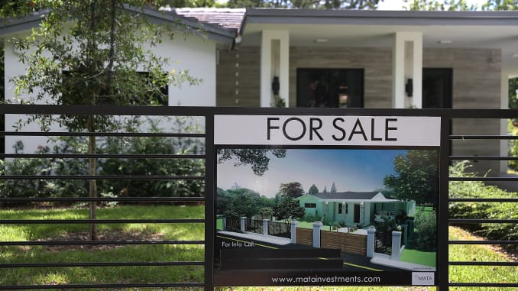
A “For Sale” sign is seen in front of a home on May 30, 2019 in Miami, Florida.
Joe Raedle | Getty Images
Pending home sales, which measure signed contracts on existing homes, fell a steeper-than-expected 21.8% in April, compared with March, according to the National Association of Realtors. Sales were down 33.8% compared with April 2019. That is the largest decline since the NAR began tracking this metric in January 2001.
“With nearly all states under stay-at-home orders in April, it is no surprise to see the markedly reduced activity in signing contracts for home purchases,” said Lawrence Yun, NAR’s chief economist.
Regionally, pending sales in the Northeast fell 48.2% month to month and were 52.6% lower than a year ago. In the Midwest, sales dropped 15.9% for the month, and were down 26% from April 2019. Sales in the South fell 15.4% monthly and 29.6% annually. In the West dropped 20% monthly and 37.2% annually.
Pending sales are a future indicator of closings one to two months out. Yun said he expects May to be the low point for closed sales.
As the nation shuttered in April in the face of the spreading coronavirus pandemic, most open houses did as well, and home sales took a deep dive. Demand, however, is already coming back, and the housing picture is starting to brighten.
“While coronavirus mitigation efforts have disrupted contract signings, the real estate industry is ‘hot’ in affordable price points with the wide prevalence of bidding wars for the limited inventory,” Yun said. “In the coming months, buying activity will rise as states reopen and more consumers feel comfortable about homebuying in the midst of the social distancing measures.”
Yun is actually raising his forecast, given what he calls, the “surprising resiliency” of the housing market. For the rest of the year he upgraded both home sales and prices, predicting home sales to decline by 11% in 2020 with the median home price projected to increase by 4%. In his prior forecast, sales were expected to fall by 15% and there was no increase in home price.
Sales of newly built homes in April, which are also based on signed contracts, beat expectations significantly, rising nearly 1% for the month. They were forecast to fall 22%. Builders have benefited from the severe shortage of existing homes for sale. They may also be seeing higher traffic from space-seeking buyers looking to flee urban apartments after the shelter-at-home orders.
Mortgage rates, which rose sharply in March, have since fallen back and hit several record lows. That should help buyers facing higher prices and potential bidding wars.

