Hello Elite Club Members! All great Sales Executives are always looking for ways to bring value to their clients either by, providing educational classes, providing strategies and business solutions, sharing economic or market trends, connecting them with our ancillary services and of course ensuring they have a great closing experience with our company. But what I wanted to share with you Elite Club Members today, is a tool to help YOU stay top of mind, accessible and relevant to your target audience. That tool is the FNTG App!

Look around the next time you are at a restaurant, store, hotel, mall or even at home…everyone is on their mobile devices. Why wouldn’t you want to have your electronic business card on the one device your clients use the most? Look at the stats below.

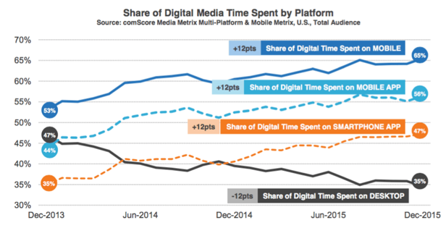

Since your app is totally customizable, you can add all the resources, links, documents or even open order forms that would make doing business with YOU easier! What could you add to your app to make it easier for your clients to choose YOU? Sales Executives with the FNTG App have clients opening and using their app 364, 268 and 215 times a month, because they’ve found a way to add value and make it easy for clients and prospects to choose them.

Call your ITS Business Solutions contact to find out how you can leverage the FNTG App to help you grow your business!

